**Usability Test Consent Form**

Please read and sign this form.

In this usability test:

* You will be asked to perform certain tasks on a computer. You can use the manual for help any time.
* After completing the tasks, you will be asked to fill a questionnaire regarding the tasks you performed. You will also be required to share your experience of using the website in this section. This questionnaire will be used to collect qualitative data.
* Further, you will be presented with another questionnaire to express your thoughts, feelings, and satisfaction level with the website. This questionnaire will be used to collect quantitative data.
* We will record the time you spend on different tasks using a stopwatch.
* You may have to give us an interview, if needed.

Participation in this usability study is voluntary. All information will remain strictly confidential. The descriptions and findings may be used to help improve our website – Canada Go. However, at no time will your name or any other identification be used. You can withdraw your consent to the experiment and stop participation at any time.

If you have any questions after today, please contact either one of the following:

* Saloni Saluja: Email - [saloni.compsc@gmail.com](mailto:saloni.compsc@gmail.com)
* Anandpreet Singh: Email – anandpreet.aps@gmail.com
* Preet Kamal Singh: Email – singh.p81@yahoo.com

I have read and understood the information on this form and had all my questions answered.

Jaskaranjit Singh JS

Subject's Name Subject’s Signature

Preet Kamal Singh 2020-04-05

Researcher’s Name Date

User Manual

How to use canada Go website

We have tried our best to keep the interface of the website as simple as possible. Thus, we did not make a huge website as it may confuse the users. After conducting surveys with our users, we concluded that users want to have a lot of information, but when presented with many choices, they tend to not choose any. So, we have tried to limit the number of options on our navigation bar, but present as much content as we can precisely under these headings.

Home Page

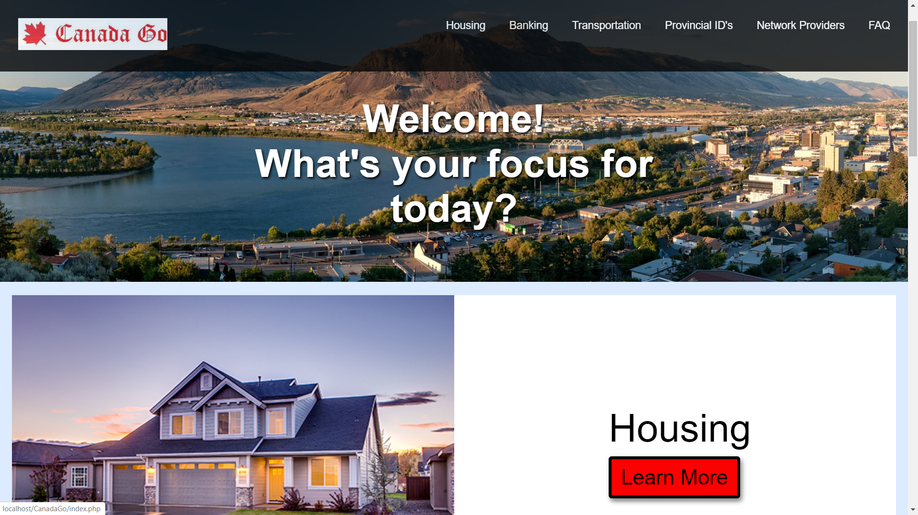

The home page aims to present you with a warm welcome by asking their focus for the day. You must enter an answer to this question on the website. However, this question probes you to think about what you are looking for, your aim of visiting this website. You can navigate through using the scrollbar on the right-hand side. As you scroll down, you are presented with several options to choose from. Let’s suppose that you wish to learn more about housing in Kamloops. To proceed with the selection, click on “Learn More”. After clicking, you will be redirected to the housing page.

HOUSING

Next comes the housing page. As you scroll down, you will be presented with the TRU on-campus housing options. A slider shows images of the three alternatives available to TRU students – North Tower, McGill Residence, and East Village.

The fraction on the top of the slider tells you which image you are currently viewing. You can scroll through the images in the slider using the left and right arrows. Another alternative for scrolling would be by clicking the image modals down below.

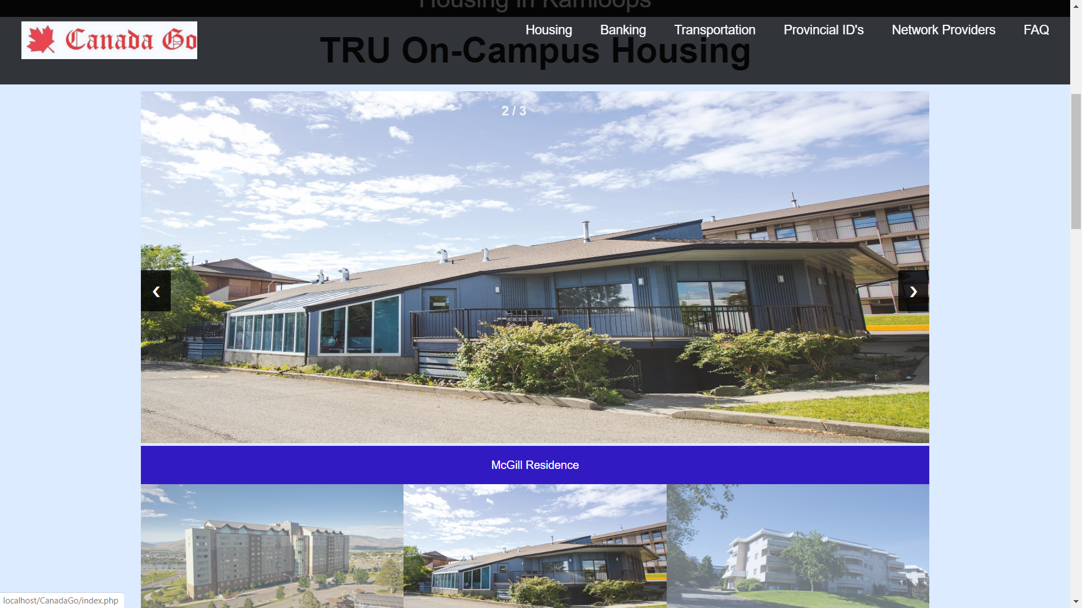

Further, we have some description of the three on-campus housing options, along with the amenities provided by each of them. They are placed side-by-side so that it is easier to have a comparative study between the three and decide which one is best suited for you.

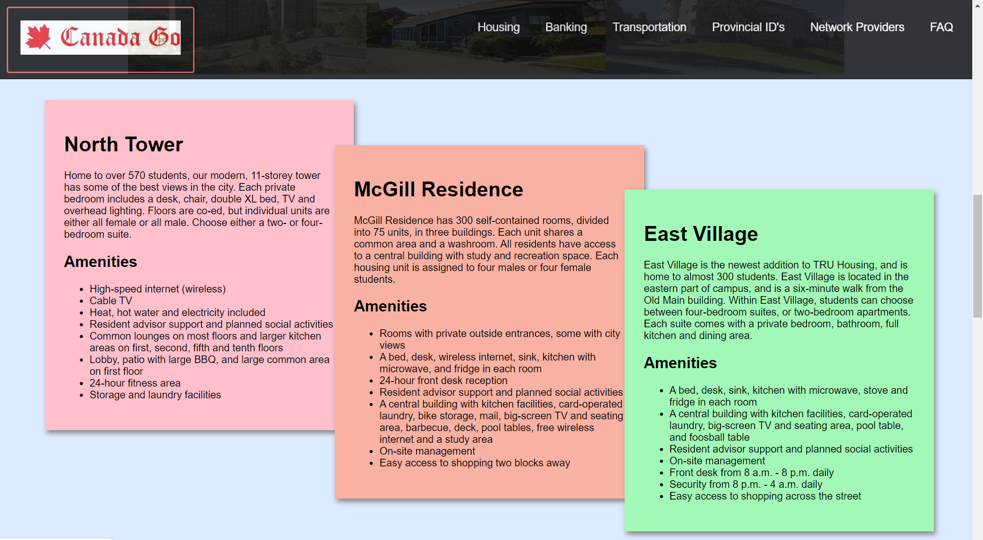

Further on, we move to off-campus housing, searching for which is one of the biggest concerns faced by international students as most of them cannot afford to live on-campus. So, here, we present you with two tables. The first table tells you about some of the hotels that reside near TRU. You can book them for a day, a week, a month, for as long as you like. The table lists the transit time taken starting from one of these hotels as the source and up to TRU. Further, it lists the services and facilities provided. Lastly, we have the charges of each of them for single occupancy, double occupancy, and triple occupancy.

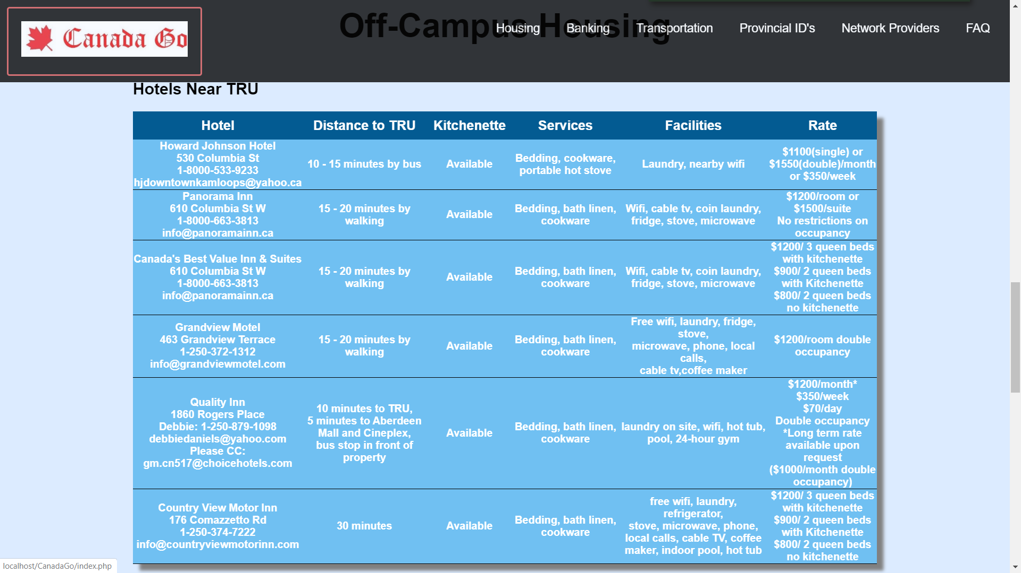

In addition to this, if you doesn’t wish to live in a hotel for long, we have also listed the names of some of the property agents in Kamloops, along with their contact information.

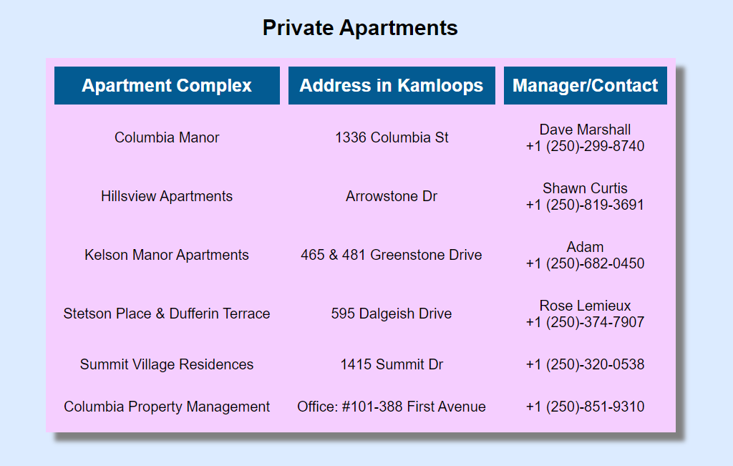

Moving ahead, we have listed some of the websites which are used by people to post rental adverts such as Kijiji, Facebook Marketplace, and Craigslist. If you wish to view some of the rental posting for Kamloops on the websites, you can click on “Learn More”.

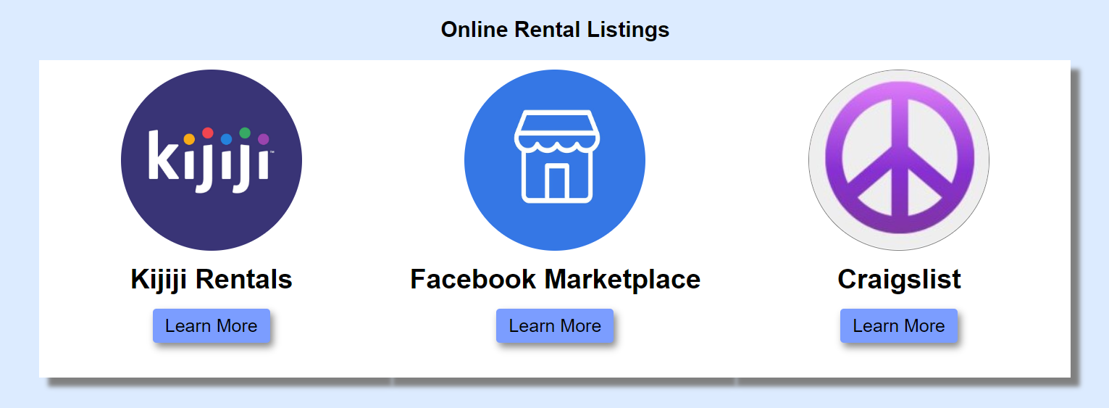

Lastly, we have a map that shows some of the locations near TRU in which a person should look for a rental. It depicts all the neigbourhood areas such as Sahali, Downtown, Aberdeen, etc.

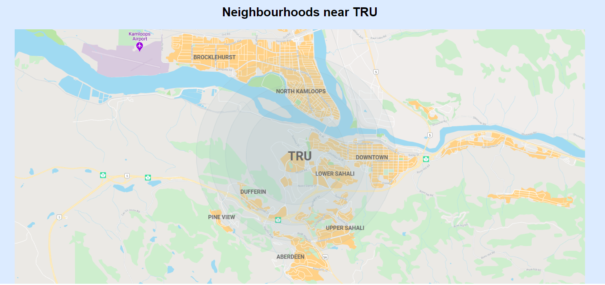

FAQ Page

We understand this fully well that a user may have a lot of questions while surfing for information on our website. Keeping this in mind, we created a page for the most frequently asked question. This page can only be accessed from the navigation bar.

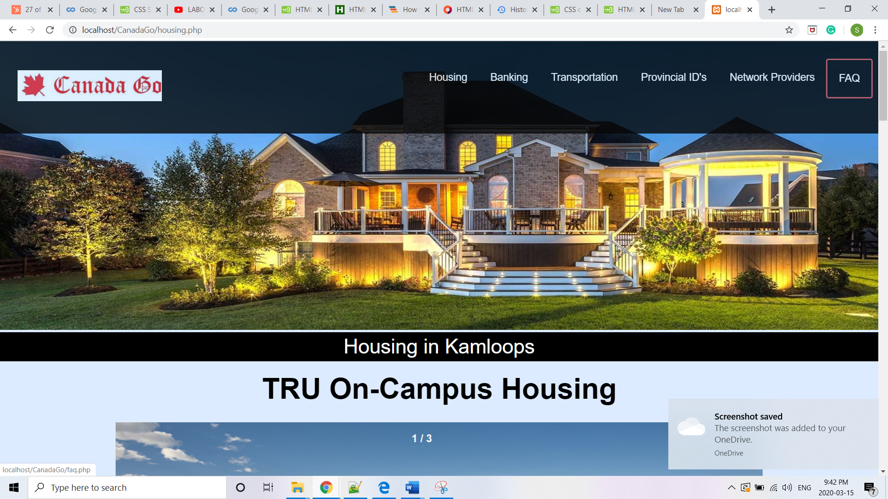

As you scroll down through the FAQ page, you come across the heart of the website. If you have any questions related to your journey to Canada, you are just a single click away. You can enter your name and email id, along with your question, and we will get back to you with an answer through email. Your details, along with the questions, are stored safely and securely with us in our database.

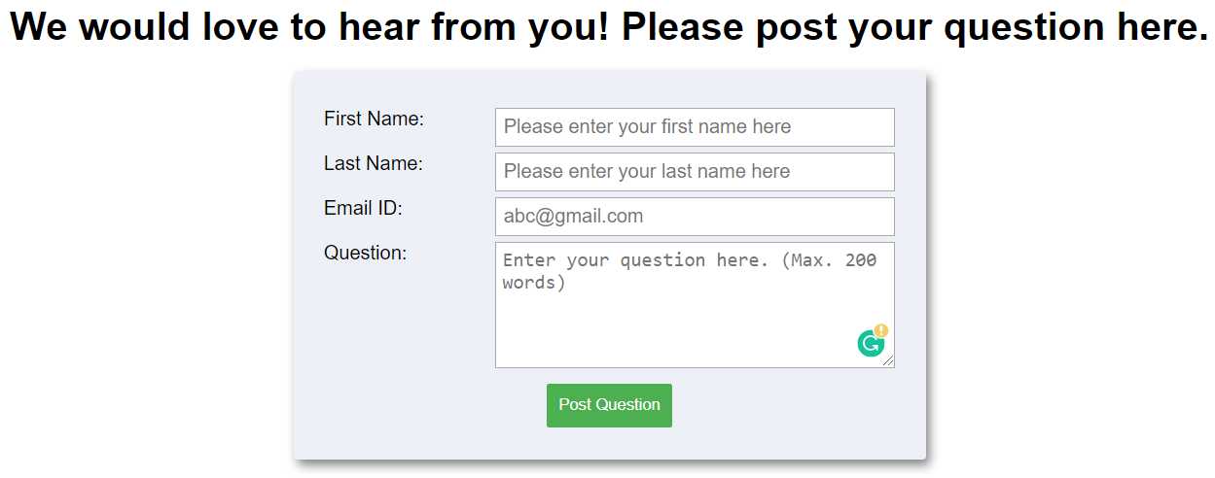

In the further sections, we have some of the most frequently asked questions regarding various subjects that have been covered in our website. The most interesting thing about these sections is that now you see two scrollbars to your right. The outer scroll bar is for the webpage, and the inner scroll bar is for the section. This makes it easy to navigate through the questions, without having to scroll a long webpage up and down again and again.



To view the answer to a question, you simply need to click on the small “+” sign flushed in the right. This expands the question to display the answer. Another way to perform the same operation is by clicking on the question.

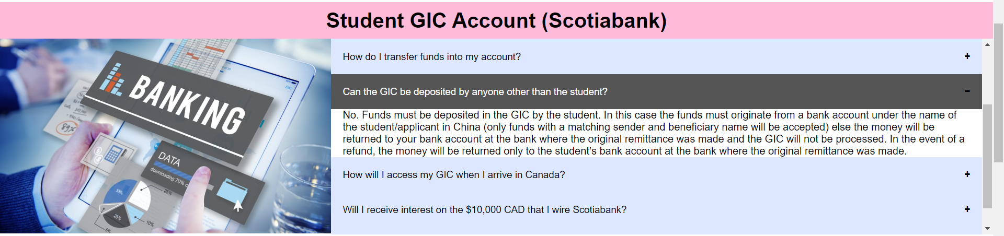

To close the answer, simply click on the question again. Alternatively, you will notice that the “+” sign has now changed to a “-” sign. You can click this sign to close the section

Task List

1. Explore the entire website.
2. Identify areas from the map which are closest to TRU.

Sahali Area

1. List the name and contact details of any one property dealer listed on the website.

Rose Lemieux

+1(250)-374-7907.

1. Write down the amount charged by Canada’s Best Value Inn and Suites for 2 Queen Beds with Kitchenette.

$900

1. Look for the price of the cheapest data plan with any phone that you like considering “Chatr”.
2. Find the bus route from North Shore to Valley View via Downtown.

1, 2, 16, 17

1. Find the type of driving license that you are eligible to apply for after 2 year of driving experience.

Class 4

1. Write down the address of place you can get your SIN number from in Kamloops.

Service Canada, Downtown.

1. Write down a question you had before coming to Canada – regarding anything covered on the website. Look for the answer to that question on the website.

Main concern for me was the transportation before coming to Canada . At that time website is not really developed but I think I got the answer to my question now.

1. Post a question on the website. Doesn’t have any question.

Questionnaire I: User Experience

1. What are some of the **design** aspects that you liked the most in the entire website? (Design aspects include aspects such as large images, font style, color combination etc.)

Color scheme and simple readable font style.

1. In your opinion, what are some of the pages that need improvement? Can you suggest some of the design improvements that you would like to see in those webpages?

According to me, the website is very easy to use and easily understandable. I guess the website design should also contains some more information with the help of photos and videos

1. What is your opinion on the color scheme used in the website? Did you like the light theme for Home Page, Housing, and FAQs, or the dark theme for rest of the pages? Why?

Color scheme is very good . yes I liked the light theme as I the font is easily readable.

1. From the list of tasks given, which task did you find the most difficult to do? (Write down the task number. Eg. Task 1)

Task 6

1. Do you think the website will be helpful to somebody looking for information before coming to Kamloops / Thompson Rivers University?

Yes.

Questionnaire II: Satisfaction Level

**Please highlight your choice.**

1. I identify myself as:
   1. Male
   2. Female
   3. Transgender
   4. I would not like to disclose
2. Which of these age groups do you belong to?
   1. 18 to 20
   2. 21 to 22
   3. 23 to 24
   4. 25 to 26
3. What is you level of study at TRU?
   1. Diploma
   2. Advanced Diploma
   3. Bachelor’s Degree
   4. Master’s Degree
4. For how long have you been studying as a full-time student on-campus in TRU?
   1. Less than 1 year
   2. 1 to 2 years
   3. 2 to 3 years
   4. 3+ years
5. How difficult was it for you to learn using the interface of the website?
6. Very Easy
7. Easy
8. Medium
9. Slightly Difficult
10. Very Difficult
11. How difficult was it for you to remember how to use the interface?
    1. Very Easy
    2. Easy
    3. Medium
    4. Slightly Difficult
    5. Very Difficult
12. How many times did you refer to the manual to perform a task?
    1. 0 times - Did not read the manual at all
    2. 1 to 2 times
    3. 3 to 4 times
    4. 5 to 6 times
    5. 7 to 8 or more times
13. Did the website provide an answer to your question?
    1. Yes
    2. No
14. Did you find any aspects in the interface that were disturbing, or anything that caused you to lose your focus?
    1. Yes
    2. No
15. How was your overall experience with the website?
    1. Excellent
    2. Very Good
    3. Good
    4. Poor
    5. Very Poor
16. Will you recommend other people to use Canada Go?
    1. Yes
    2. No